Cape York Natural Resource Management Ltd.

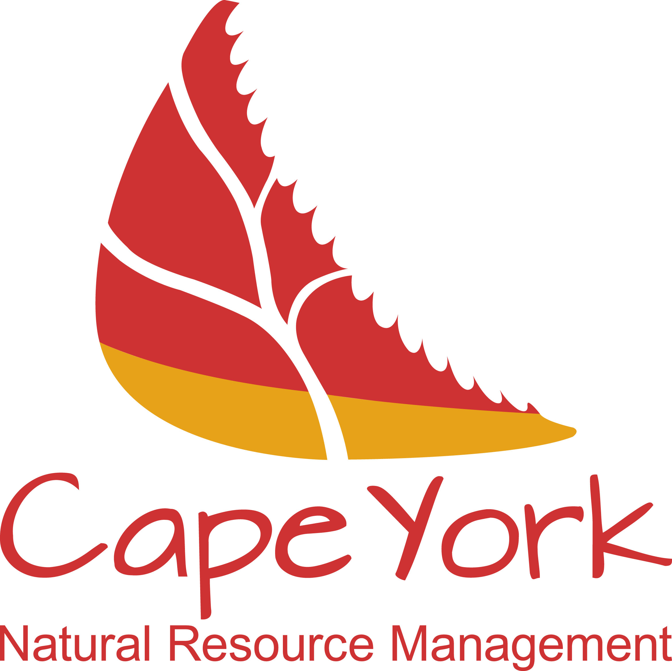

Invitation to Tender
No CYNRMT01/19
For the provision of review of existing and development of an alternative Cape York Fire Funding methodology

Response Form

Tender’s Name:

Contact Name:

Phone Number:

e-mail address:

Table of Contents

Part 1. Tenderer Authorisation and Certification

Part 2. Proposed Goods and/or Services and Pricing

Part 3. Schedules informing Conditions of Contract

Part 4. Declaration of commission and incentives, conflict of
interest and collusion

Part 5. Check List

Attachment A SCHEDULE 3 -SCOPE OF ENGAGEMENT

Part 1. Tenderer Authorization and Certification

Information Required | Details
Please specify the type of legal entity: | Individual  Company  Incorporated Association  Partnership  Trust  Other (specify)
Please specify the legal name of the tenderer:
Tenderer’s Australian Company Number (CAN) if applicable
Tenderer’s Australian Business Number (ABN):
Tenderer’s Registered Business Name
Is the Tenderer registered for GST?
State or Territory in which the Tenderer’ Business/Corporation is registered:
Name of Holding Company if applicable:
Does Your Tender include a Business Profile ? | Yes No

Tenderer’s Postal Address:
Tenderer’s Street Address (registered office address of the Tenderer):
Contact Name:
Contact Phone:
Contact E-mail:
Contact Fax:
Is it proposed to sub-contract any part of the Goods and/or Services?  If “YES”, please specify full name and address of each sub-contractor and their relevant experience and expertise in relation to the offered Goods and/or Services: | Yes No
Are Notices relating to the potential Contract to be directed to the above Contact Name and details?  If ‘NO”, please insert alternative details: | Yes No

Authorisation, Certification and Execution by Tenderer (company)
The Director and Director/Secretary named below certify that in submitting the Tender on behalf of the Tenderer:
(a) they have read, understood and complied with the requirements of the Invitation;
(b) the enclosed Response Form is a true and accurate account of their Tender; and
(c) they have provided details of any proposed Additional Provisions in Response Form 6.3.
Signed for and on behalf of:  Tenderer:  ABN:  ACN:  in accordance with s.127 of the Corporations Act 2001 (Cth)  this ………… day of ………….. 201 ……..  by:  (insert full name of Director )  (insert full name of Director or Company Secretary) | Signature of Director  _________________________________  Signature of Director/Company Secretary
OR
Authorisation, Certification and Execution by Tenderer (Individual ,
Incorporated Association, Partnership, Trust or other entity.
I, the Tenderer/authorised signatory named below, certify that in submitting the Tender:
(a) I have read, understood and complied with the requirements of the Invitation;
(b) the enclosed Response Form is a true and accurate account of the Tender;
(c) I have provided details of any proposed Additional Provisions in Response Form 6.3; and
(d) I am duly authorised to execute this Tender on behalf of the Tenderer.
Signed for and on behalf of:  Tenderer:  ABN:  this ………… day of ………….. 201 ……..  by:  (insert full name of Tenderer or authorised signatory) or  (insert full name of Witness) | Signature of Tenderer/Authorised Signatory  _________________________________  Signature of Witness

Part 2. Proposed Goods and/or Services and Pricing

The Goods and/or Services and Pricing offered by the Tenderer are as follows:

Description | Unit Offer Price  (Excl. GST) |  | Offer Price (GST component only) |  | Total Offer Price  (Incl. GST)
insert Goods and/or Services item description | $ |  | $ |  | $
insert Goods and/or Services item description | $ |  | $ |  | $
insert Goods and/or Services item description | $ |  | $ |  | $
insert Goods and/or Services item description | $ |  | $ |  | $
insert Goods and/or Services item description | $ |  | $ |  | $
insert Goods and/or Services item description | $ |  | $ |  | $
insert Goods and/or Services item description | $ |  | $ |  | $
insert Goods and/or Services item description | $ |  | $ |  | $
insert Goods and/or Services item description | $ |  | $ |  | $
insert Goods and/or Services item description | $ |  | $ |  | $
insert Goods and/or Services item description> | $ |  | $ |  | $
TOTAL OFFER PRICE |  |  |  |  | $

Other Pricing Considerations

Description | Response
Specify any conditions that may affect the pricing offered in their Tender. | <<insert conditions that may affect the Pricing offered >>
Please specify any other Price or cost that may be charged to Cape York NRM for the supply of the Goods and/or Services under the Invitation.  For each Price, specify:  - the nature of the Pricing;  - the circumstances under which it will be incurred; and  - total Price (including GST). | <<insert details of any other Price that may be charged to Cape York NRM for the supply of the Goods and/or Services>>
Specify if the Prices offered are  “Firm” - that is the Price does not change for the Contract Term; | Yes No
If NO, specify reasons per budget item
insert Goods and/or Services item description
insert Goods and/or Services item description
insert Goods and/or Services item description

Part 3. Schedules informing Conditions of Contract

If a contract is awarded to the tenderer the information provided in this part of the response will form part of that contract
No. | Reference  Clause No. | Contract – Reference Clause | Details
1. | Consultancy Agreement  Schedule 1 | Customer | Name:  Cape York Natural Resource Management Ltd.  ABN/ACN: 89146770167  Address: PO Box 907 Atherton QLD 4883  Office: 47 Maunds Road, Atherton  Telephone: 07 40957133
2. | Consultancy Agreement  Schedule 1 | Consultant | Name:  insert full legal name of Consultant  ABN/ACN:  Address:  Telephone:  Facsimile:  Email:  Contact Person:  name of the person representing the Contractor for the Contract
3. | Consultancy Agreement  Schedule 1 | Commencement date | insert the date on which the Contract is to commence
4. | Consultancy Agreement  Schedule 3 | Final milestone completion date | insert the date on which the Contract is to conclude
 | Consultancy Agreement  Schedule 1 | Contract Term (Period of engagement) | insert the term of the Contract
5. | Consultancy Agreement  Schedule 3 | Delivery Date (goods only) | insert the delivery date by which the Goods are to be supplied
6. | Consultancy Agreement  Schedule 4 | Performance of Key Personnel  Are Key Personnel associated  with the Contract?  If “YES”, please specify the names  and qualifications of personnel who are to undertake the Services for the Contractor. | Yes No  Name:  Qualifications:
7. | Consultancy Agreement  Schedule 1 | Project Manager  (NEED TO AMEND Schedule 1 of consultancy agreement template) | Name:  Position:  Telephone:  Mobile:  Email:
8. | Consultancy Agreement  Schedule 3 | Provision of the Goods and/or Services  Have you attached a description of the proposed milestones and achievement dates at Attachment A  of this Response to Tender?  If a Contract is awarded to  the Tenderer as a result of the Invitation Process Schedule3 will be completed by Cape York NRM in accordance with the Tender or as otherwise negotiated between the Parties and accepted by Cape York NRM and will form part of the Consultancy Agreement | Yes No
9. | Consultancy Agreement  Schedule 3 | Provision of the Goods and/or Services – periodic or recurrent Services | insert times/frequency/intervals for the performance of periodic or recurrent Services. If Services are not periodic or recurrent, insert “Not Applicable”
10. | Consultancy Agreement  Section 15 | Is there any part of the Tender of concern to the Tenderer, if released under the Right to Information Act 2009 (Qld)?  If “YES”, please specify the component of your Offer and which of the following categories it relates to:  Note: This information is being sought for the purposes of applying any relevant exemptions that might be available under the Right to Information Act 2009 (Qld). However, Cape York NRM can give no guarantee to the Tenderer that the information will be protected from disclosure under the Right to Information Act 2009 (Qld). | Yes No  if “YES”, please specify the component of your tender is of concern  Please specify which of the following categories is applicable to the above component: (delete those not applicable)  Trade Secret  Commercial value  Results of research  Confidential nature
11. | Consultancy Agreement  Section 7 | Intellectual Property Rights in New Contract Material  Have you read and understood and are you prepared to enter into an agreement containing Section 7 of Cape York NRM’s Contractor Agreement | Yes No
12. | Consultancy Agreement  Section 8 | Moral Rights  List any specific acts or omissions in relation to Moral Rights that are being proposed in your Tender.  If no acts or omissions are to be specified insert ‘NIL’ or ‘Not Applicable’
13. | Consultancy Agreement  Schedule 2 | Insurance – Public Liability  Is Public Liability insurance required?  Public liability insurance covers liability for personal injury and property damage. Typically the amount is at least $10 million per claim depending upon the Risk Assessment. | Yes No  If “YES” then please specify the following:  Sum Insured:  Policy No.:  Insurance Provider:  Named Insured:  Expiry Date of Policy:
14. | Consultancy Agreement  Schedule 2 | Insurance - Professional indemnity  Is Professional Indemnity Insurance required?  Professional indemnity  insurance covers the consequences  of a breach of professional duty  and professional negligence.  It is only required where  relevant, (e.g. if you engage  a lawyer, accountant or auditor to  provide professional services). | Yes No  If “YES” then please specify the following:  Sum Insured:  Policy No.:  Insurance Provider:  Named Insured:  Expiry Date of Policy:
15. | Consultancy Agreement Schedule 2 | Insurance - Other insurances  Is other insurance (e.g. WorkCover) required? | Yes No  If Yes’ then please specify the following:  Type of insurance:  Sum Insured:  Policy No:  Insurance Provider:  Named Insured:  Expiry Date of Policy:
16. | Consultancy Agreement Schedule 2 | Notices – Customer’s address for notices | Address:  PO Box 907  Atherton 4884  Email:  jgreenwood@capeyorknrm.com.au
17. | Consultancy Agreement Schedule 2 | Notice - Contractor’s address for notices | Address:  Facsimile No:  Email Address:
18. | Consultancy Agreement Section 9 | Dispute Resolution | Delegate:  Position:  Telephone:  Email:

Part 4. Declaration of commission, incentives or conflict of interest

1. Commission and Incentives (clause 23.1 of Conditions of Offer)
In submitting its Tender, the Tenderer warrants to Cape York NRM that to the best of its knowledge, as at the date of the Tender, that :
- no family, business or pecuniary relationships exist between the Parties to the Invitation Process that would adversely impact on the Invitation or any Contract established as a result of the Invitation Process;
- neither the Tenderer nor its officers, employees, agents and/or sub-contractors have:
  - engaged in any unethical behavior or sought and/or obtained an unfair advantage; or
(ii) received or will receive any pecuniary or in-kind advantage from any other Tenderer,
in relation to the Invitation Process;
- no officer, employee, agent, sub-contractor or family member associated with the Tenderer is or has been engaged by Cape York NRM in a position or role that in any way relates back to the Tender; and
- no officer, employee, agent, sub-contractor or family member associated with Cape York NRM has been offered any benefit or inducement associated with the Tender, including any offer relating to employment.
The Tenderer must immediately notify the Contact Officer in writing if any warranty contained in this Response Form becomes incorrect.

2. Conflict of Interest (clause 23.3 of Conditions of Offer)
Tenderers must supply details of any possible Conflict of Interest that exists or may arise in relation to the Invitation to Tender Process.
If there is nothing to declare, Tenderers must insert “Nil”.
<< insert details, if applicable>>
<< insert details, if applicable>>
<< insert details, if applicable>>

Part 5. Check List

 | Check List Questions | Have you met this requirement:
1 | Have you read and understood the Conditions of Offer Version 004 - dated 1 July 2012, as referenced in Section 2 of the Invitation? | Yes No N
2 | Have you read and understood the Conditions of Contract Version 004 - dated 1 July 2012, as referenced in Section 5 of the Invitation? | Yes No
3 | Are you submitting your Offer in accordance with Section 1 of the Invitation? | Yes No
4 | Have you signed your Offer on the “Offer Authorization and Certification” page of Response Form? | Yes No
5 | Have you completed Response Form Part 4 Declaration of Commissions and Incentives, Conflict of Interest and Collusion? | Yes No
6 | Have you answered all questions and responded to all requirements specified in the Response Forms? | Yes No
7 | Have you entered the name of your organization making the Offer in the footer of each Response Form (where applicable)? | Yes No
8 | Have you checked all other lodgment requirements of the Invitation to ensure your Offer is prepared and addressed correctly? (Refer to Section 1 and Section 2 of the Invitation)? | Yes No

Attachment A

Schedule 3 Scope of Engagement (including Milestones and progress payments)

# | Milestones and Activities | Deliverables and Outputs | Completion date  (Milestone must be completed on or before this date) | Instalment amount  (excluding GST)
Total investment $### GST Exclusive
1 | Pre-signing meeting (Consultant and Cape York NRM representatives) followed by execution of this Consultancy Agreement and receipt of WH&S documentation (outlined in Project Proposal and/or Work Safety Plan) | Return Consultancy Agreement  Provide Tax Invoice  WH&S documentation provided and compliant with Work Health and Safety Act 2011 | Start Date (as per Schedule 1) | $###
2 | e.g. Engagement, plan or survey/study report:  Activities include: <details> | e.g. provide approved report/plan/document; provide evidence of activity completion | Date | e.g. $###  OR  non-financial hurdle
3 | e.g. Work with CYNRM to deliver progress report, approved by CYNRM and Consultant | e.g. Provide progress report, approved by both parties | Date | e.g. $###  OR  non-financial hurdle
4 | e.g. On-ground works  Activities include: <details> | e.g. provide evidence of works, including:  - photos,  - videos,  - spatial data | Date | e.g. $###  OR  non-financial hurdle
5 | e.g. Provision of data and outputs for the project | e.g. provision of monitoring and evaluation data and information, including:  - reports,  - maps,  - audio-visual information,  - web pages,  - communications materials etc. | Date | e.g. $###  OR  non-financial hurdle
6 | e.g. Financial reporting | e.g. Provision of audited Financial report | Date | e.g. $###  OR  non-financial hurdle
Sub-total: |  |  |  | $###
GST: |  |  |  | $###
Total: |  |  |  | $###

